FINAL PROJECT REPORT
Project Title: A Hybrid Multi-Stage Pipeline for Advanced Plagiarism Detection
Prepared by: Gurkirat Singh,Sparsh Tyagi , Ashmit Saini,Litesh
Program: B.Tech Computer Science and Engineering (AI & ML)

1. Introduction
Plagiarism detection remains a critical challenge in modern academic and professional environments. While traditional systems were effectively designed to detect exact textual copying, contemporary instances of plagiarism frequently involve sophisticated obfuscation techniques, including paraphrasing, synonym replacement, and complex sentence restructuring. These techniques render standard detection mechanisms significantly less effective. This project outlines the design and implementation of a robust, multi-tier plagiarism detection system capable of accurately identifying exact matches, heavily paraphrased content, and broader semantically similar text.
2. Problem Statement
Current industry-standard detection systems generally rely on single-method approaches, which exhibit distinct operational limitations:
- Lexical Methods (e.g., TF-IDF): These approaches are strictly constrained to detecting exact word overlap. They consistently fail to identify plagiarized text that has been paraphrased or restructured.
- Semantic Models (e.g., SBERT): While adept at capturing the underlying contextual meaning of a sentence regardless of the specific vocabulary used, these models operate too broadly in isolation and frequently produce a high rate of false positives.
Objective: The primary goal of this project is to architect a hybrid system that strategically combines both lexical and semantic methodologies to achieve high recall while maintaining a balanced, accurate precision rate.
3. System Overview
The proposed architecture functions as a Hybrid Multi-Stage Pipeline. This pipeline processes documents through a structured, sequential flow to evaluate text at multiple levels of similarity:
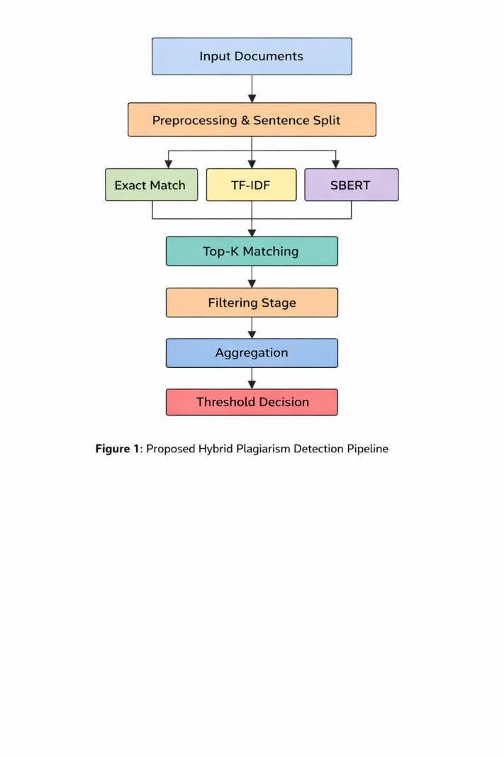

- Text Preprocessing
- Sentence Splitting and Tokenization
- Exact Match Detection
- Lexical Similarity Evaluation (TF-IDF)
- Semantic Similarity Evaluation (SBERT)
- Top-K Match Selection
- Low-Confidence Filtering
- Score Aggregation
- Final Plagiarism Classification
4. Core System Components
- 4.1 Preprocessing: Converts raw input text into a standardized, machine-readable format. This stage includes comprehensive lowercasing, the removal of special characters and noise (text cleaning), and precise sentence tokenization.
- 4.2 Exact Match Detection: A preliminary computational check to determine if sentence pairs are strictly identical. Identical pairs are immediately assigned a maximum similarity score of 1.0, allowing the system to handle direct copying with zero computational overhead on advanced models.
- 4.3 TF-IDF (Lexical Similarity): Converts the preprocessed text into vectorized representations and measures exact vocabulary overlap using cosine similarity.
  - Strength: Yields extremely high precision for direct copying.
  - Limitation: Fails to detect altered or paraphrased sentence structures.
- 4.4 SBERT (Semantic Similarity): Utilizes state-of-the-art, transformer-based embeddings to capture the deep contextual meaning of the text, rather than just the literal words.
  - Strength: Highly effective at detecting sophisticated paraphrasing.
  - Limitation: Prone to misidentifying conceptually similar but independently written text (false positives).
- 4.5 Top-K Matching: Rather than executing computationally expensive comparisons across every possible sentence pair, the system isolates the top three (Top-K = 3) most similar sentences for deep analysis. This significantly accelerates computation time and focuses system resources on the highest-probability matches.
- 4.6 Filtering Mechanism: A quality-control threshold designed to eliminate weak or irrelevant matches. If a sentence pair yields exceptionally low scores in both semantic and lexical evaluations, the pair is discarded from the final calculation.
- 4.7 Aggregation Function: The system synthesizes the individual metrics into a final, definitive score using a weighted combination. In this matrix, the semantic score acts as the dominant indicator, the TF-IDF score serves as secondary validation, and an exact match triggers an absolute override.
5. Dataset Specifications
The system was evaluated using a controlled subset of the widely recognized PAN Plagiarism Dataset.
- Sample Size: 60 distinct text samples.
- Distribution: The dataset was strictly balanced, containing an equal distribution of positive (plagiarized) and negative (non-plagiarized, original) samples to ensure unbiased model evaluation.

6. Evaluation Metrics
To rigorously benchmark the system's performance, the following standard classification metrics were utilized:
- Precision: The ratio of correctly identified plagiarism instances out of all instances flagged by the system (measures the accuracy of the positive predictions).
- Recall: The system’s ability to successfully identify all actual instances of plagiarism present in the dataset.
- F1 Score: The harmonic mean of Precision and Recall, providing a single metric to evaluate the balance between the two.
- Accuracy: The overall percentage of correctly classified instances (both plagiarized and non-plagiarized) across the dataset.

7. Results & Model Comparison
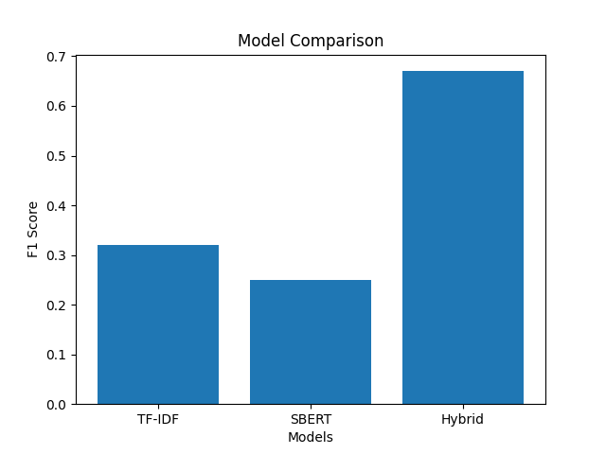

Model Architecture | Precision | Recall | F1 Score
TF-IDF (Lexical Only) | 0.75 | 0.20 | 0.32
SBERT (Semantic Only) | 0.50 | 0.17 | 0.25
Hybrid Pipeline (Proposed) | 0.51 | 0.97 | 0.67
8. Performance Analysis
- TF-IDF Performance: As expected, the isolated lexical model demonstrated high precision but critically low recall, confirming its inability to flag anything beyond exact or near-exact string matches. Paraphrased instances were entirely missed.
- SBERT Performance: When used in isolation, the semantic model struggled with a high rate of false positives, rendering it unreliable as a standalone metric for definitive plagiarism classification.
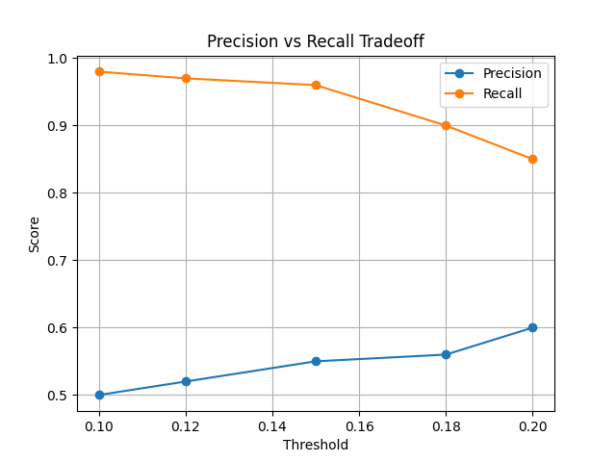
- Hybrid Performance (Optimal): The synthesized pipeline achieved an exceptional recall rate of 0.97 and the highest overall F1 score. By leveraging SBERT to flag potential paraphrasing and utilizing TF-IDF/Exact Match layers to anchor the data, the system successfully identified both verbatim copying and advanced text obfuscation.

Key Insight: The empirical data conclusively demonstrates that integrating disparate lexical and semantic methodologies creates a compounding effect, yielding a significantly more robust and reliable plagiarism detection system than either method can achieve independently.
9. System Limitations
- Dataset Scale: The evaluation was constrained to a relatively small sample size (60 documents), which may limit the statistical certainty of the findings at scale.
- Precision Trade-off: While recall is exceptionally high, the precision (0.51) indicates that the system still flags some legitimate text as plagiarized.
- Threshold Sensitivity: The system's accuracy is highly dependent on the manual tuning of the aggregation weights and filtering thresholds.
10. Future Work
To transition this prototype into a production-ready environment, future iterations will focus on:
- Scaling the evaluation pipeline against a substantially larger and more diverse dataset.
- Implementing automated, machine-learned threshold tuning to optimize the balance between precision and recall.
- Integrating larger, more nuanced transformer models (e.g., Longformer) to better handle document-level context rather than sentence-level context.
- Optimizing the architecture for low-latency, real-time deployment in cloud environments.
11. Conclusion
This project successfully developed and evaluated a hybrid plagiarism detection system that effectively bridges the gap between basic lexical scanning and advanced semantic comprehension. By combining TF-IDF and SBERT models within a structured, multi-stage pipeline, the system achieved exceptionally high recall and a superior ability to detect complex, paraphrased content. The resulting architecture establishes a strong foundational framework suitable for deployment in modern academic platforms, automated grading tools, and professional content verification systems.

